# **Inheritance**

**Types of Inheritance:**

**Single Inheritance:** When a class extends to another one class only, then it is called single inheritance.

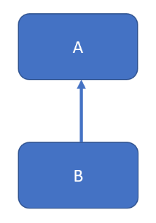

**Multilevel Inheritance:** In Multilevel inheritance, we have a base class and we extend this class from a child class and this class will be extended from another child class.

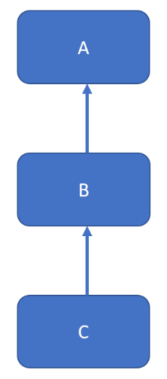

**Hierarchical Inheritance:** In hierarchical inheritance a single class will be extended by multiple classes.

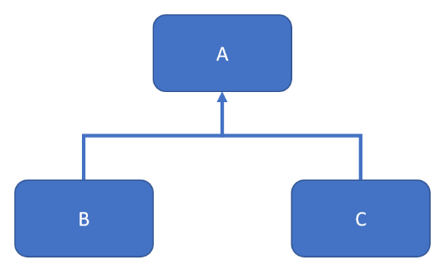

**Multiple Inheritance:** In multiple inheritance a single class extends multiple classes.

Java doesn’t support multiple inheritance for classes. It is supported for interfaces only.

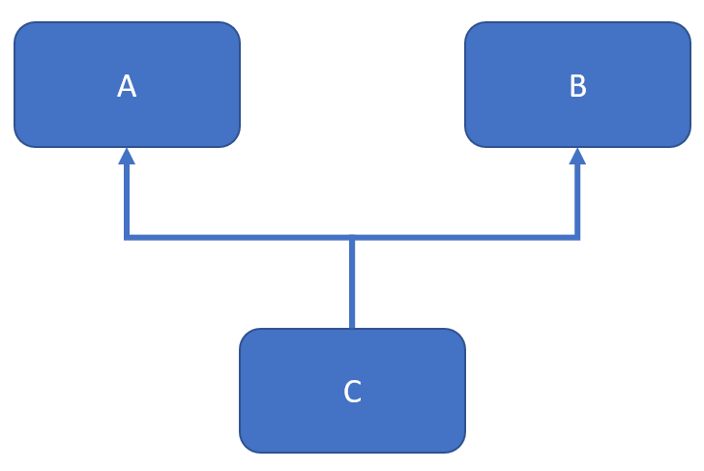

**Hybrid Inheritance:** It’s a combination of single and multiple inheritance.

